

**DEPARTMENT OF ELECTRICAL AND ELECTRONIC ENGINEERING**

**EEE416(18/19) Coding and Cryptography**

*Lab 1 - Source coding and channel capacity EEE416*

**Lab Report**

|  |  |  |
| --- | --- | --- |
| Student Name | : | Enge Xu |
| Student ID | : | 1821635 |
| Date | : | 2019/4/4 |
| Professor | : | Liming Yu |

# ABSTRACT

This assessment aims at evaluating students’ understanding and problem solving skills involved in information theory, source coding and channel capacity analysis, which are accumulated during lectures, tutorials and after-class study.

**TASK**

**Question 1: Entropy, Joint Entropy and Mutual Information** (25 points)

Consider two random variables, X and Y with their joint probability mass function as

follows:

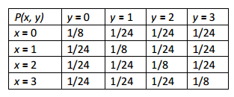

Determine the following (round your answers up to two decimals):

i) The marginal Entropies H(X) and H(Y). (8 points)

ii) The joint entropy H(X, Y). (4 points)

iii) The conditional entropies H(X|Y) and H(Y|X). (8 points)

iv) The mutual information between them I(X, Y). (5 points)

**Solution**

The answer is shown as below;

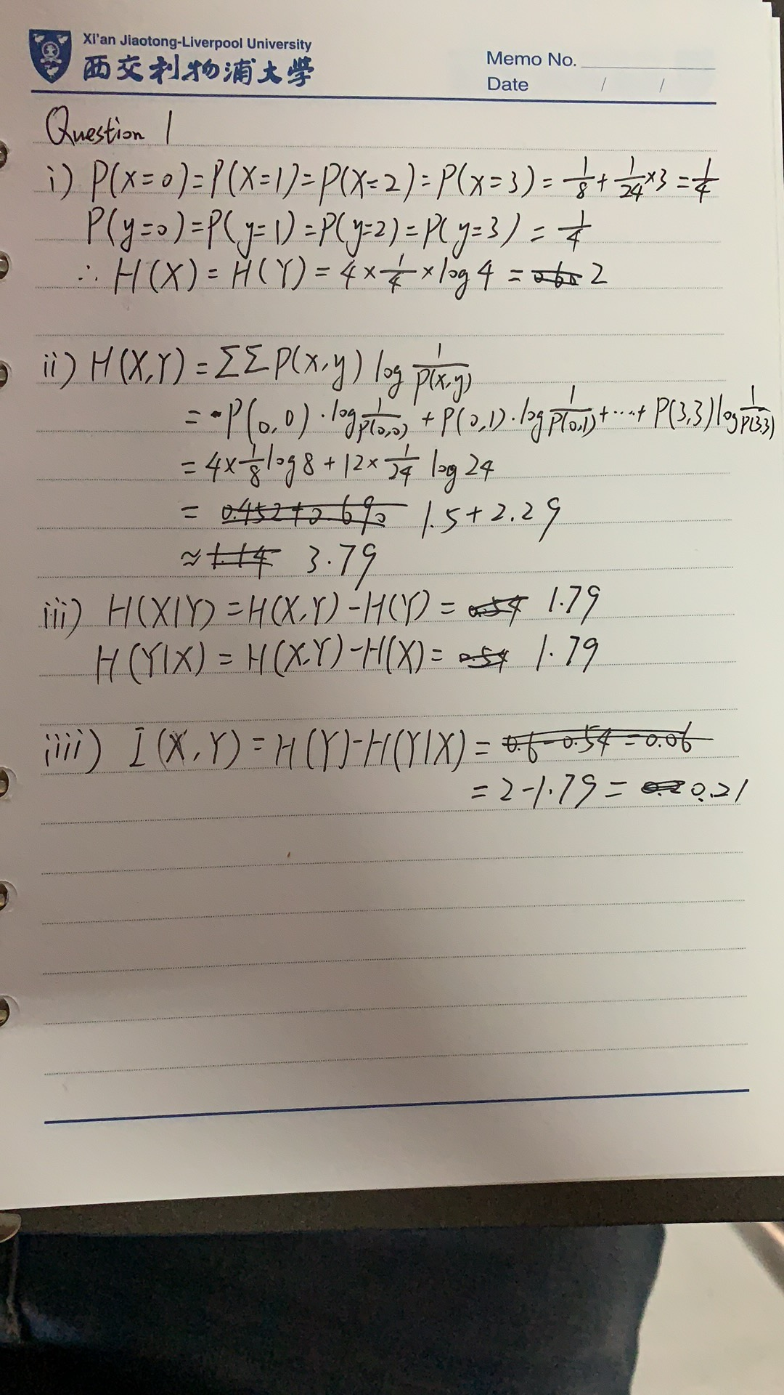

**Question 2: Huffman Coding** (25 points)

A discrete memoryless source has an alphabet X = {1, 2, 3} with symbol probabilities P(X) = {0.8 0.1, 0.1}.

i) Construct an extended Huffman code which encodes two source symbols at a time.

(10 points)

ii) Calculate the average codeword length. (4 points)

iii) Calculate the coding efficiency of the extended Huffman code. (6 points)

iv) Compare coding efficiency of the original source and extended Huffman code.

Interpret the significance of extended coding scheme. (5 points)

**Solution**

The answer is shown as below;

1. To construct the extended Huffman code, first generate the new symbol list and

rank them in descending order according to their probabilities:

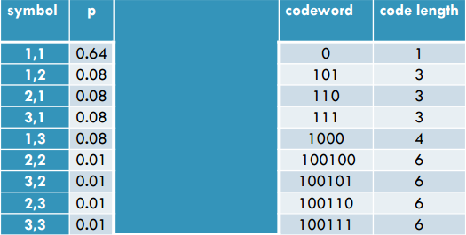

(The intermediate stages are too tedious so they are omitted here.)

The resultant codewords and code lengths are listed in above table.

2. The average code length is given by

L2 = 0.64 × 1 + (0.08 × 3 × 3) + (0.08 × 4) + 0.01 × 6 × 4 = 1.92 bits

3. The entropy of the extended code is H(A2) = 2H(A) = 2*0.9219 = 1.8438 bits.

So the efficiency of the extended code is

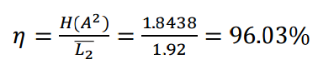

1. The coding efficiency of the original source is

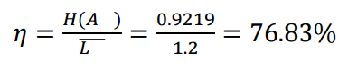

The efficiency of the extended Huffman code is higher than the original Huffman

code. It could be proved by the SIC of the compound symbol that conforms to the

typical set.

**Question 3: Universal Source Coding (Lempel-Ziv Algorithm)** (25 points)

Given the following binary sequence: 01001111100101000001010101100110111

i) Using the Lempel-Ziv algorithm to encode the sequence. (15 points)

ii) Demonstrate the decoding procedure. (10 points)

(Hint: Parse the sequence to determine the required fixed codeword length and fill the

dictionary entries according to procedure.)

**Solution**

The answer is shown as below;

|  |  |  |  |  |
| --- | --- | --- | --- | --- |
| Entry ID | Current Symbol | Next Symbol | Index | Codeword |
|  | NULL | 0 | 0000 |  |
| 1 | 0 | 1 | 0001 | 00000 |
| 2 | 1 | 0 | 0010 | 00001 |
| 3 | 00 | 1 | 0011 | 00010 |
| 4 | 11 | 1 | 0100 | 00101 |
| 5 | 111 | 0 | 0101 | 01001 |
| 6 | 001 | 0 | 0110 | 00111 |
| 7 | 01 | 0 | 0111 | 00011 |
| 8 | 000 | 0 | 1000 | 00110 |
| 9 | 0010 | 1 | 1001 | 01100 |
| 10 | 10 | 1 | 1010 | 00100 |
| 11 | 101 | 1 | 1011 | 10101 |
| 12 | 100 | 1 | 1100 | 10100 |
| 13 | 110 | 1 | 1101 | 01000 |
| 14 | 111 | - | 1110 | 01001 |

Decoding procedure:

0000|0 => NULL + ‘0’

0001|1 => NULL + ‘1’

0001|0 => ‘0’ + ‘0’ => ‘00’

0010|1 => ‘1’ + ‘1’ => ’11’

0100|1 => ‘11’ + ‘1’ => ‘111’

0011|1 => ‘00’ + ‘1’ => ‘001’

0001|1 => ‘0’ + ‘1’ => ‘01’

0011|0 => ‘00’ + ‘0’ => ‘000’

0110|0 => ‘001’ + ‘0’ => ‘0010’

0010|0 => ‘1’ + ‘0’ => ‘10’

1010|1=> ‘10’ + ‘1’ => ‘101’

1010|0 => ‘10’ + ‘0’ => ‘100’

0100|0 => ‘11’ + ‘0’ => ‘110’

0100|1 => ‘11’ + ‘1’ => ‘111’

**Question 4: Channel Capacity** (25 points)

Consider the channels A and B as shown in the figure below.

i) Find the capacity of channel A. (12 points)

ii) Find the capacity of channel B. (13 points)

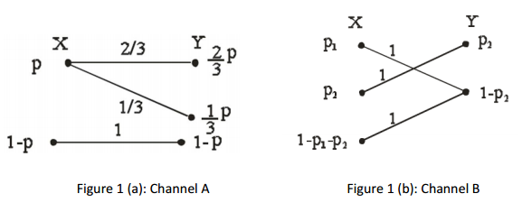

**Solution**

The answer is shown as below;

i)

I(X;Y) = 2/3*p log1/p+1/3*p log1/p+(1-p) log 1/1-p

= p log1/p+(1-p) log 1/1-p

ii)

I(X;Y) = p2 log1/p2 + p1 log1/1-p2 + (1-p1-p2) log 1/1-p2

= p2 log1/p2 + (1-p2) log 1/1-p2